How a Query Executes in Snowflake (Detailed Explanation)
When you run a query in Snowflake, it goes through several stages, from parsing to execution and result caching. Here’s a step-by-step breakdown of the query lifecycle in Snowflake:
Step 1: Query Submission
- A user submits a query via Snowflake Web UI, JDBC/ODBC connection, API, or BI tools (e.g., Power BI, Tableau). The query is sent to Snowflake's cloud services layer.
Step 2: Query Parsing & Optimization
(a) Parsing
- Snowflake first validates the syntax of the query. It checks for SQL correctness (e.g., missing keywords, incorrect table names). If the query is invalid, an error message is returned immediately.
(b) Security & Privilege Checks
- Snowflake checks if the user has the required privileges to execute the query (e.g., SELECT, UPDATE). If the user lacks permission, the query fails. If query passes the above stages, the query would be compiled into a relational operator tree.
(c) Query Optimization
- Snowflake’s Query Optimizer rewrites the query for efficiency.
- It considers factors like:
  - Predicate Pushdown (pushing filters down to reduce data scanning).
  - Column Pruning (fetching only required columns).
  - Join Reordering (optimizing table joins for better performance).
  - Aggregation Pushdown (reducing computation by aggregating early).
Step 3: Query Execution
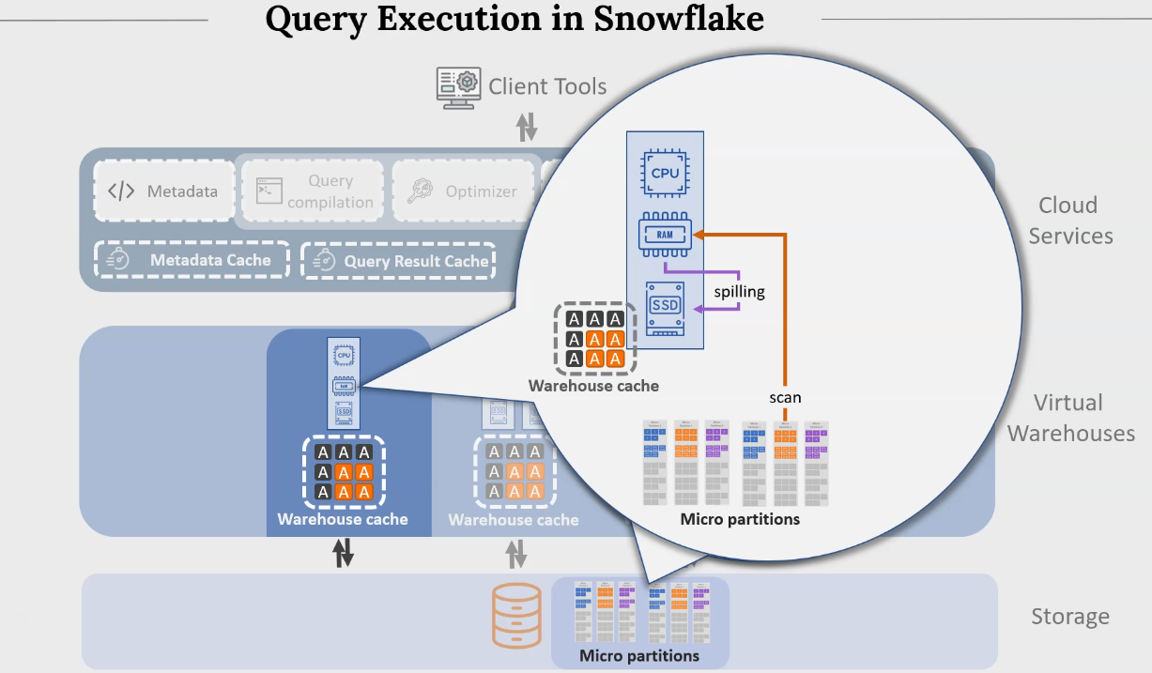
Snowflake determines the necessary compute resources and allocates virtual warehouses for further execution. If the warehouse is suspended, Snowflake automatically resumes it. VW executes the query by following the execution plan. Execution involves reading one/more micro partitions, where micropartition pruning occurs.
Each warehouse unit comprises of CPU, RAM and SSD. Data will be brought to RAM and if it does not fit in the Ram then data gets spilled to the disk. As query execution progresses, the warehouse cache gets created to store the data that might get used by future queries. Once the query execution is complete, the result will be saved in Query Result cache
(b) Query Processing in Compute Layer
- The compute layer reads data (Mup) from storage and processes the query. Snowflakes use MPP (Massively Parallel Processing) to split the work into multiple tasks across compute nodes.
(c) Query Caching
- Snowflake automatically caches results to improve performance:
  - Metadata Cache (in Cloud Services Layer) – Stores query execution plans.
  - Result Cache (for 24 hours) – If the same query runs again, Snowflake fetches results instantly instead of re-executing.
  - Local Disk Cache (in Virtual Warehouse) – Stores frequently accessed data on SSDs.
  - Remote Cache (in Cloud Storage Layer) – Stores columnar data on AWS S3, Azure Blob Storage, or GCS.

Step 4: Data Fetching & Result Formation
- The final results are assembled and sent back to the user. If the same query is re-executed, Snowflake may use cached results instead of running it again. The query history & execution stats are stored for monitoring and optimization.

Step 5: Query Completion & Auto-Suspend
  - If no new queries are submitted, the Virtual Warehouse auto-suspends (to save costs). Users can view the query history & execution details in: Snowflake UI (QUERY_HISTORY view). Account Usage Tables (SNOWFLAKE.ACCOUNT_USAGE.QUERY_HISTORY). Information Schema (INFORMATION_SCHEMA.QUERY_HISTORY).

Massive Parallel Processing (MPP) in Snowflake refers to the architecture and approach Snowflake uses to process queries and perform operations across a distributed set of resources, or compute nodes, simultaneously. MPP is a key part of Snowflake's ability to handle large-scale data processing tasks efficiently, enabling it to scale horizontally and perform complex analytics quickly.

How MPP Works in Snowflake:
- Multiple Compute Nodes: Snowflake operates with multiple virtual compute clusters (also called "virtual warehouses"), each of which can independently process a subset of the data. These warehouses work in parallel, which allows for the simultaneous execution of tasks across different nodes.
- Distributed Data Storage: Data in Snowflake is stored in a distributed fashion across different storage nodes, with the data split into smaller chunks (called micro-partitions). This distribution ensures that the data is spread across multiple compute nodes, so each compute node can focus on processing its share of the data.
- Parallel Query Execution: When a query is submitted, Snowflake breaks it into smaller tasks, which are distributed to the available compute nodes. Each node processes its assigned portion of the query, and the results are then combined to return the final output. This parallel execution of tasks significantly reduces query time.
- Separation of Compute and Storage: One of Snowflake’s unique features is the decoupling of compute resources (virtual warehouses) and storage. Snowflake can scale compute resources independently, meaning that you can increase the number of compute nodes dedicated to a query or workload without impacting storage capacity. This separation enables highly efficient, parallel execution of queries without any interference or bottleneck between storage and compute.
Key Benefits of MPP in Snowflake:
- Scalability: As the data grows or as the query load increases, Snowflake can scale compute resources by adding more virtual warehouses, which allows for parallel execution. This makes it easy to handle large datasets and high-demand workloads without impacting performance.
- Performance: MPP architecture allows Snowflake to split complex queries into smaller tasks and execute them in parallel, which leads to faster query execution. This is particularly useful for data warehousing and analytics tasks that require processing large volumes of data.
- Isolation of Workloads: Snowflake allows different virtual warehouses to operate independently of each other. This means that one virtual warehouse running a large query doesn’t impact other workloads or queries. Multiple workloads can be executed in parallel without performance degradation.
- Cost Efficiency: Snowflake’s ability to scale compute resources dynamically means you only pay for the compute power you need. You can allocate more compute resources during peak times and scale down during idle periods, helping optimize costs while maintaining performance.
Example:
If you run a large aggregation query in Snowflake, such as calculating the total sales per region over millions of records, Snowflake can split that query into smaller tasks, where each virtual warehouse processes a portion of the dataset. The results are then combined to provide the final answer, greatly reducing the time it would take if only a single node were performing the operation.
In Snowflake, vectorized processing refers to the ability to process multiple data elements simultaneously using a single instruction. This type of processing allows Snowflake to execute database operations (like queries and data transformations) more efficiently by utilizing modern CPU architectures that support SIMD (Single Instruction, Multiple Data) operations.

